INHERITANCE IN GLOBAL CLASS
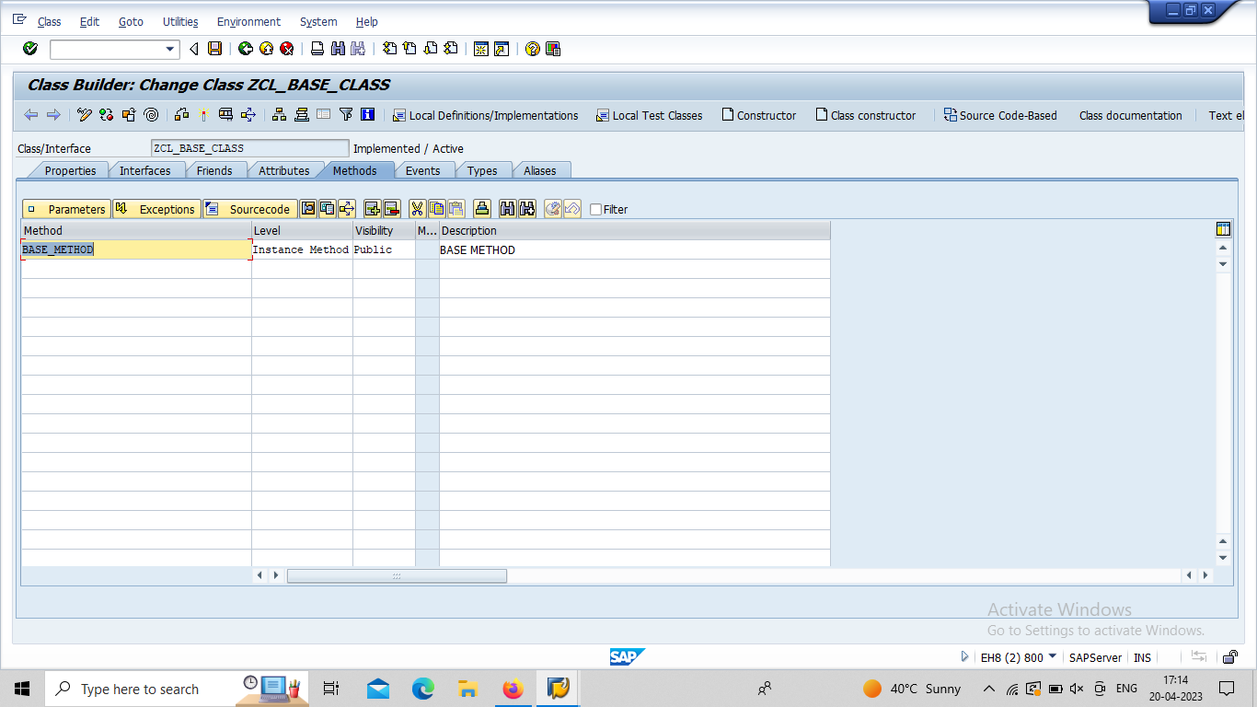

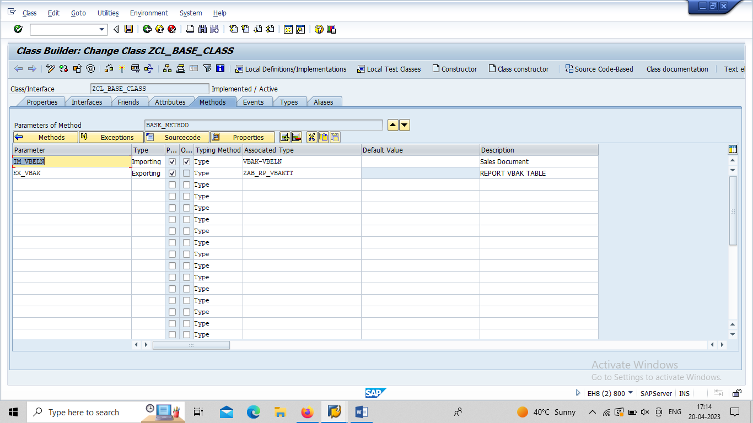

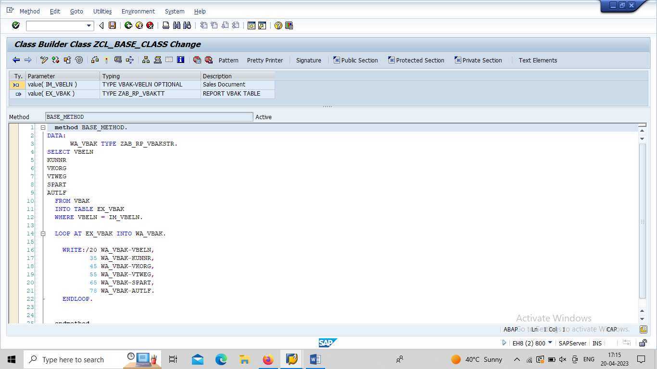

CALL SECOND CLASS.

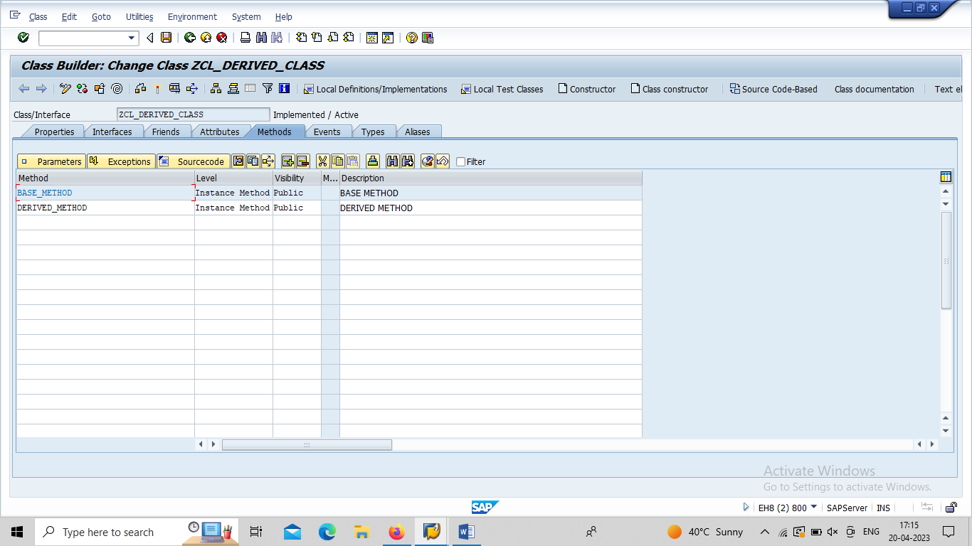

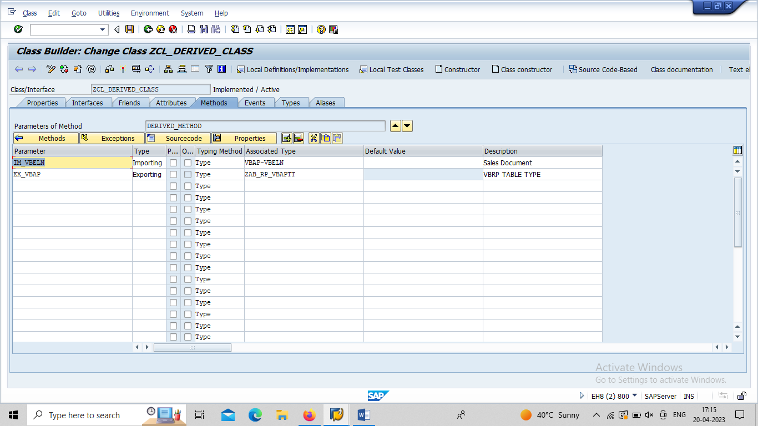

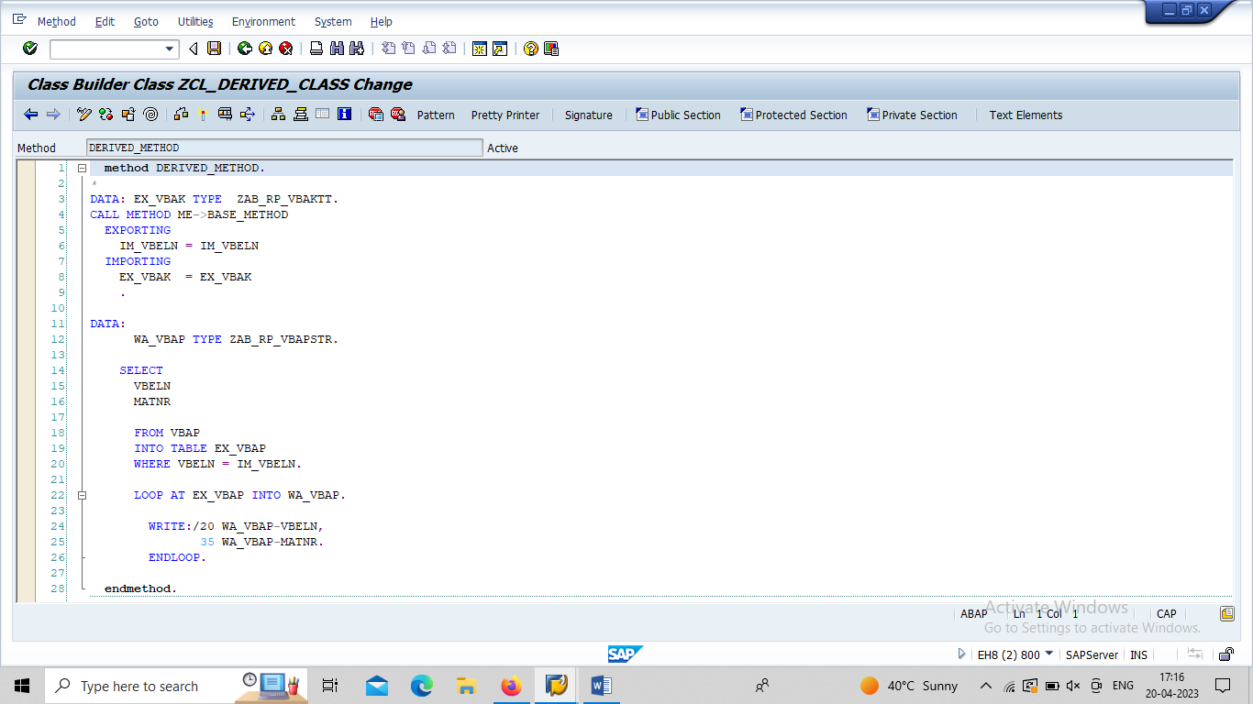

CALL SE38.
*&---------------------------------------------------------------------*
REPORT Z23_OOABAP_DEMO_06_GL.
DATA:
IT_VBAP TYPE ZAB_RP_VBAPTT,
VBELN TYPE VBELN,
OBJ TYPE REF TO ZCL_DERIVED_CLASS.
PARAMETERS: P_VBELN TYPE VBELN.
CREATE OBJECT OBJ.
CALL METHOD OBJ->DERIVED_METHOD
EXPORTING
IM_VBELN = P_VBELN
IMPORTING
EX_VBAP = IT_VBAP.

